Bright Future Grant Overview
Bright Future Grant Funding: For the 2026-2027 Fiscal Year, South Madison Community Foundation (SMCF) will make $200,000 available to advance initiatives specified below. Funded projects are expected to be completed within one year of the date of award. Requests should range from $2,000 to $15,000. Recipients may be awarded more than one time during a year, but no single organization shall receive more than $15,000 in cumulative awards in FY26/27.
Eligible applicants will be 501(c)3 public charities, 501(c)4 social welfare organizations, or 509(a)1 public entities for projects that serve charitable purposes. Grants to non-charities require expenditure responsibility and will be considered on a case-by-case basis. While your organization does not need to have a physical location in South Madison County, the project should provide direct benefit to residents of Adams, Fall Creek, Green and/or Stony Creek Townships of Madison County, Indiana. Prospective applicants are encouraged to schedule a Strategic Alignment meeting with SMCF to discuss your proposed project. Applications are due by the 5th day of each month, with applicants notified of funding decisions at the start of the following month.

Contact Associate Director Kerry Dodd at kerry@southmadisonfoundation.org or 778-8444 with questions or to schedule a meeting. For more information about SMCF, visit www.SouthMadisonFoundation.org

Our mission is to connect residents, support local organizations, and propel transformative and sustainable impact that enriches lives across South Madison County.
Our Initiatives:
Enhance Physical Spaces & Interpersonal Connections
Unmet Needs
Raise awareness and foster empathy for people in need.
Invest in and advocate for universal accessibility and inclusive public policies.
Encourage Lifelong Learning & a Resilient Economy
Expand upon current youth development offerings.
Build a robust college/career/community pipeline.
Support educational offerings for lifelong learners.
Our vision is for South Madison County to be a caring and connected community that enjoys natural amenities, an active civic life, economic vitality, and a philanthropic culture. We will pursue this vision through our roles as catalyst, connector, educator, and funder.
Ally with anchor institutions to plan and deliver exemplary service to residents.
Equip residents to become informed on civic matters and to serve in public roles.
Support efforts to preserve, protect, restore and expand greenspaces.
Invest in community amenities that foster social engagement and mental well-being.
Expand Civic Capacity

Our grant practices are designed to be approachable and responsible. We go above and beyond the norm in proving timely funding, useful feedback, and connections and coaching to individuals and groups that seek our assistance.

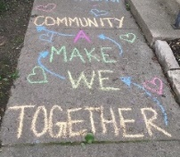
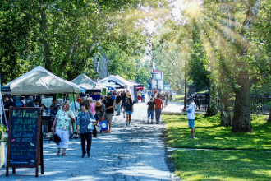
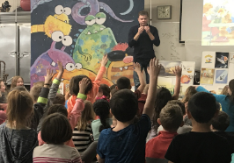
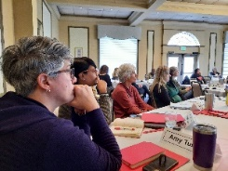
2026/2027 Bright Future Grant Application
Applying Organization Name:
Contact Person/Position:
Email Address:
Telephone Number:
Mailing Address:
Do we have your permission to share your proposal with other funders?
PROJECT NAME:
PROJECT SUMMARY: In one paragraph, summarize your project and the benefit it will bring to South Madison County.
Please answer each of the following questions as they relate to your proposed project. Be succinct, yet thorough.
1. ORGANIZATION: Tell us about your organization and its mission.
2. PROJECT DESCRIPTION: Describe your project and how it fits within your organization.
3. RATIONALE: How will this project benefit South Madison County?
4. WHICH TOWNSHIPS or AREAS ARE SERVED BY YOUR PROJECT?
qAdams/Markleville qFall Creek/Pendleton qGreen/Ingalls qStony Creek/Lapel qMadison County
5. ALIGNMENT: Which Foundation initiatives will your project address? Select as many as apply.
- Address Unmet Needs - Raise awareness and foster empathy for people in need; sponsor and promote service delivery for people in need; invest in and advocate for universal accessibility and inclusive public policies
- Encourage Lifelong Learning and a Resilient Economy - Expand upon current youth development offerings; build a robust college/career/community pipeline; support educational offerings for lifelong learners
- Enhance Physical Spaces and Interpersonal Connections - Support efforts to preserve, protect, restore, and expand greenspaces; invest in community amenities that foster social engagement and mental well-being
- Expand Civic Capacity - Ally with anchor institutions to plan and deliver exemplary service to residents; equip residents to become informed on civic matters; build awareness about civic matters and to serve in public roles

6. OBJECTIVES: What are the measurable goals of your project?
GOAL | MEASUREMENT | TIME FRAME

7. PARTNERSHIPS: Describe how you will engage the community in this project.
8. FUNDRAISING PLAN: Describe how this project fits within your organization’s overall budget, how you plan to fund it in its entirety, and sustain it after grant funding is expended.
9. PROJECT BUDGET: List specific expenses and income sources relative to this project.
EXPENSES | AMOUNT
INCOME | AMOUNT
Bright Future Grant Request

